Common API Security Methods - API Keys

🔐 What is API Keys
# Source: AI Source: Provided by: [Data Path: Persons Table -> ID Column: 1, Name_En Column: Motasem Essam] -> From: [ChatGPT] on [1/19/2026]
API Keys are a simple method of authenticating clients by providing a unique key (token) with each request. The server uses this key to identify and track the client.
👉 Think of an API Key as a username for your application (but not a full security solution by itself).

🔑 Key Points
# Source: AI Source: Provided by: [Data Path: Persons Table -> ID Column: 1, Name_En Column: Motasem Essam] -> From: [ChatGPT] on [1/19/2026]
- Unique identifier assigned to each client
- Sent with every API request
- Used to track usage and apply rate limits
- Typically not tied to a specific user identity (unlike OAuth/JWT)

🧱 Example
# Source: AI Source: Provided by: [Data Path: Persons Table -> ID Column: 1, Name_En Column: Motasem Essam] -> From: [ChatGPT] on [1/19/2026]
Request with API Key (Header)
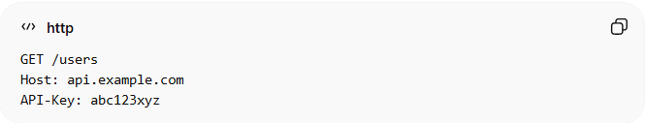
GET /users
Host: api.example.com
API-Key: abc123xyz
Alternative: Query Parameter (Less Secure)
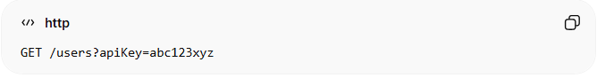
GET /users?apiKey=abc123xyz

⚙️ How It Works
# Source: AI Source: Provided by: [Data Path: Persons Table -> ID Column: 1, Name_En Column: Motasem Essam] -> From: [ChatGPT] on [1/19/2026]
- Client sends request with API key
- Server validates the key
- If valid → request is processed ✅
- If invalid → request is rejected ❌

✅ Advantages
# Source: AI Source: Provided by: [Data Path: Persons Table -> ID Column: 1, Name_En Column: Motasem Essam] -> From: [ChatGPT] on [1/19/2026]
- Simple and easy to implement
- Useful for public APIs or low-security scenarios
- Helps with rate limiting and usage tracking

❌ Disadvantages
# Source: AI Source: Provided by: [Data Path: Persons Table -> ID Column: 1, Name_En Column: Motasem Essam] -> From: [ChatGPT] on [1/19/2026]
- Not very secure alone (can be leaked or stolen)
- No built-in user-level authorization
- Hard to manage for complex systems

⚠️ Common Mistakes
# Source: AI Source: Provided by: [Data Path: Persons Table -> ID Column: 1, Name_En Column: Motasem Essam] -> From: [ChatGPT] on [1/19/2026]
- Sending API keys in URLs (can be logged/exposed) ❌
- Hardcoding API keys in frontend code ❌
- Not rotating or expiring keys ❌

🔐 Best Practices
# Source: AI Source: Provided by: [Data Path: Persons Table -> ID Column: 1, Name_En Column: Motasem Essam] -> From: [ChatGPT] on [1/19/2026]
- Send API keys via headers, not query params
- Always use HTTPS
- Combine with rate limiting and monitoring
- Rotate keys regularly
- Restrict usage (IP, domain, permissions)

💡 Summary
# Source: AI Source: Provided by: [Data Path: Persons Table -> ID Column: 1, Name_En Column: Motasem Essam] -> From: [ChatGPT] on [1/19/2026]
API Keys identify the client, but they do not fully secure the API — they should be combined with stronger methods (like OAuth or JWT) for sensitive systems.

